**Case Studies & Guesstimates for FinTech Industries**

The FinTech industry has emerged as a dynamic and transformative force in the financial sector, integrating technology with financial services to enhance efficiency, accessibility, and customer experience. In today's era, FinTech is crucial for democratizing financial services, providing underserved populations with access to banking, credit, and investment opportunities. It fosters innovation through digital payment systems, peer-to-peer lending platforms, and blockchain technology, revolutionizing traditional banking practices.

Data scientists play a pivotal role in the growth of FinTech by leveraging advanced analytics and machine learning to improve risk assessment, fraud detection, and personalized financial services. Their expertise enables FinTech companies to analyze vast amounts of financial data, uncovering insights that drive strategic decision-making, optimize operations, and enhance customer satisfaction. By harnessing the power of data, data scientists help FinTech firms stay competitive, innovate continuously, and contribute to a more inclusive and efficient financial ecosystem.

**PART - I**

**Product Dissection**

**1. Platform Selection**

**Question:** Choose a leading platform from a domain related to the **e-commerce** industry. Justify your selection by discussing the platform's popularity, impact, and relevance in its industry.

**Answer : Paytm**

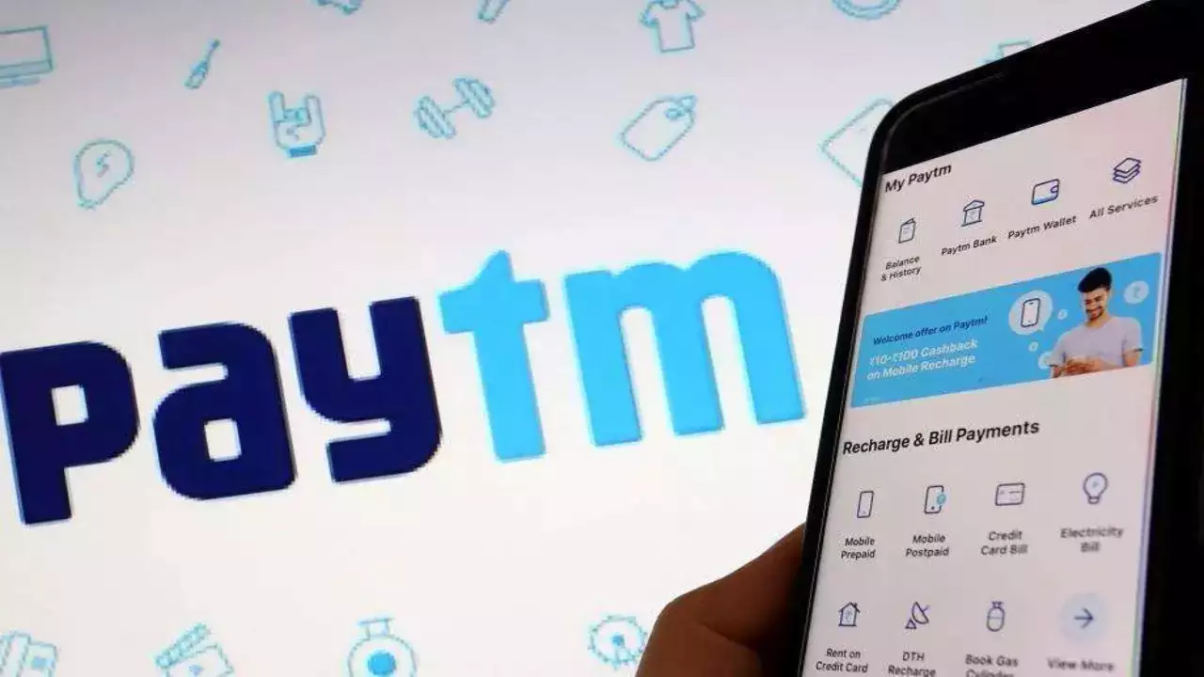

**1. Popularity:**

Paytm is one of India's most popular digital payment platforms, with a broad user base across the country. It offers a wide range of services, including digital wallet, UPI payments, bill payments, recharges, ticket booking, and e-commerce. The platform has millions of active users, making it a household name in India. Its popularity is driven by its ease of use, extensive merchant network, and promotional offers.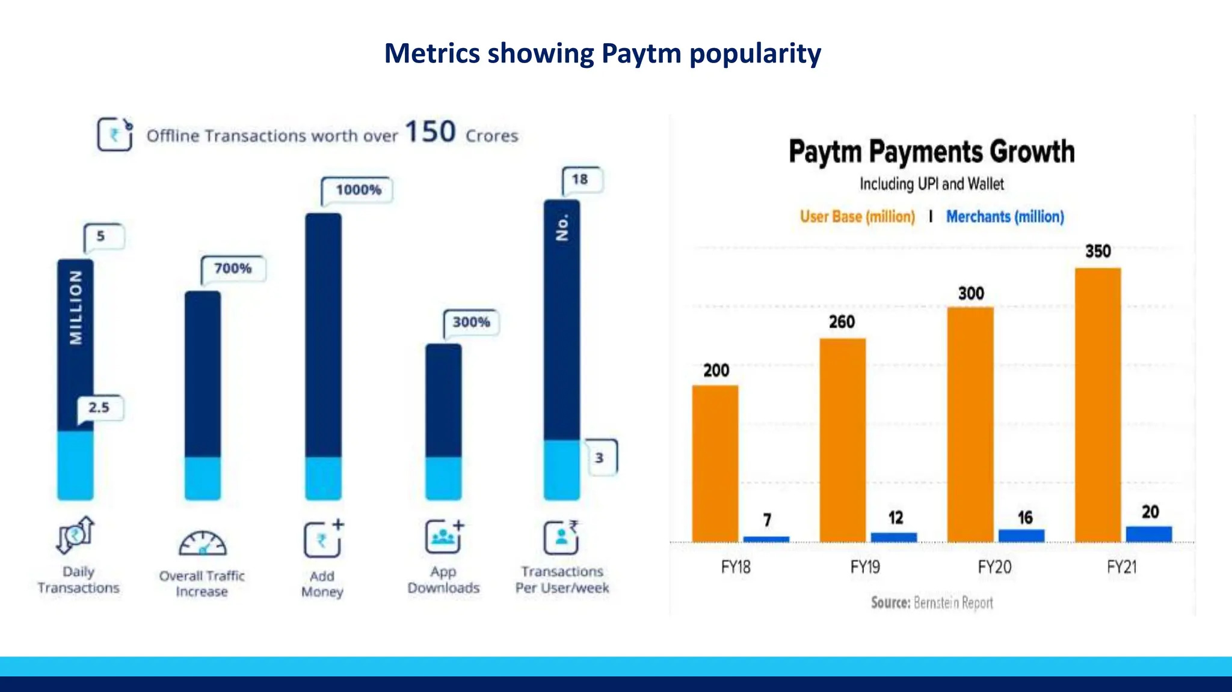

**2. Impact:**

Paytm has had a significant impact on the digital payments landscape in India. It was one of the pioneers in promoting cashless transactions, especially during the demonetization period in 2016, which accelerated the adoption of digital payments. The platform has empowered millions of small and medium-sized businesses by providing them with access to digital payment solutions. Additionally, Paytm has expanded into financial services, including banking, mutual funds, and insurance, further broadening its impact on the financial ecosystem.

**3. Relevance:**

Paytm's relevance in the current fintech landscape is substantial. As India continues to push towards digitalization and financial inclusion, Paytm's comprehensive suite of services makes it a crucial player in the industry. It caters to various demographics, from urban consumers to rural users, and supports government initiatives such as Digital India and financial literacy. The platform's relevance is further bolstered by its continuous innovation and adaptation to changing market needs, such as integrating UPI payments and launching Paytm Payments Bank.

**2. Core Features and Functionalities**

**Question:** Research and list the core features and functionalities of the selected platform. Describe how these features contribute to the platform’s success and user engagement.

**Paytm Core Features and Functionalities**

1. **Digital Wallet and Payments:**
   * **Digital Wallet:** Allows users to store money and make quick transactions. Users can add money to their wallets using debit/credit cards, net banking, or UPI.
   * **Peer-to-Peer Transfers:** Enables users to send and receive money instantly to/from other Paytm users.
   * **Bill Payments and Recharges:** Facilitates payments for utilities like electricity, water, gas, and mobile/DTH recharges.
   * **QR Code Payments:** Merchants can generate QR codes for customers to scan and pay seamlessly using the Paytm app.
2. **Contribution to Success:**
   * **Convenience:** Simplifies transactions and reduces the need for cash handling.
   * **Speed:** Instant transfers enhance user experience.
   * **Security:** Secure transactions build user trust.
   * **Wide Acceptance:** QR code payments allow small merchants to accept digital payments, expanding user base and engagement.
3. **Unified Payments Interface (UPI):**
   * **UPI Integration:** Users can link multiple bank accounts and perform transactions using UPI IDs.
   * **Instant Transfers:** Facilitates real-time bank-to-bank transfers without needing account details.
4. **Contribution to Success:**
   * **Interoperability:** Enhances user convenience by integrating multiple bank accounts in one app.
   * **Efficiency:** Streamlines the payment process, promoting frequent use.
5. **Banking Services:**
   * **Paytm Payments Bank:** Offers savings accounts, fixed deposits, and digital debit cards.
   * **Interest Rates:** Competitive interest rates on savings and fixed deposits attract users.
6. **Contribution to Success:**
   * **Financial Inclusion:** Provides banking services to underserved segments.
   * **User Retention:** Integrated banking services keep users engaged within the Paytm ecosystem.
7. **E-commerce and Ticketing:**
   * **Online Shopping:** Paytm Mall offers a wide range of products, including electronics, fashion, and groceries.
   * **Ticket Booking:** Users can book movie, bus, train, and flight tickets.
8. **Contribution to Success:**
   * **Diverse Offerings:** Broadens the use case for the app, increasing user engagement.
   * **One-stop Solution:** Combines shopping and ticketing with payments, enhancing user convenience.
9. **Financial Services:**
   * **Loans and Credit Cards:** Provides personal loans and credit card services through partnerships with banks.
   * **Insurance:** Offers insurance products like health, life, and travel insurance.
10. **Contribution to Success:**
    * **Accessibility:** Makes financial services more accessible to a broader audience.
    * **User Loyalty:** Enhances the platform's value proposition, encouraging users to stay within the Paytm ecosystem.
11. **Investments:**
    * **Mutual Funds:** Users can invest in mutual funds directly through the Paytm app.
    * **Gold:** Allows users to buy, sell, and store digital gold.
12. **Contribution to Success:**
    * **Diversification:** Adds investment options, catering to users looking for financial growth.
    * **Trust:** Establishes Paytm as a comprehensive financial platform.
13. **Business Solutions:**
    * **Paytm for Business App:** Provides tools for merchants to manage payments, view transactions, and generate reports.
    * **POS Devices:** Offers point-of-sale devices for merchants to accept card payments.
14. **Contribution to Success:**
    * **Merchant Engagement:** Empowers small and medium businesses with digital tools, expanding Paytm's merchant network.
    * **Ecosystem Growth:** Enhances the overall ecosystem by integrating merchants and consumers.
15. **Paytm Mini App Store:**
    * **Mini Apps:** Allows developers to create mini-apps within the Paytm ecosystem, offering services like food delivery, ride-hailing, and more.
16. **Contribution to Success:**
    * **Innovation Platform:** Encourages developers to innovate and expand Paytm's service offerings.
    * **User Retention:** Keeps users engaged by offering diverse functionalities within the same app.
17. **Customer Support and User Experience:**
    * **24/7 Customer Support:** Provides round-the-clock customer service through chat, email, and phone.
    * **User Interface:** Intuitive and user-friendly interface enhances user experience.
18. **Contribution to Success:**
    * **Trust and Reliability:** Strong customer support builds user trust.
    * **Ease of Use:** A seamless interface ensures user satisfaction and retention.

**Overall Contribution to Platform's Success and User Engagement**

Paytm's diverse range of features and functionalities caters to various user needs, making it a versatile and comprehensive digital platform. By integrating payments, banking, e-commerce, financial services, and business solutions into a single app, Paytm offers a one-stop solution for users, enhancing convenience and engagement. The platform's focus on security, speed, and user experience builds trust and loyalty, while continuous innovation and expansion of services keep users engaged and attract new users. Paytm's ability to address both consumer and merchant needs further strengthens its ecosystem, driving its success in the competitive digital market.

### **3. Real World Problems**

**Question:** Identify the real-world problems that the platform aims to solve. Discuss how the platform addresses these problems through its features and functionalities.

**Answer:** Here are some key issues it tackles and how it addresses them through its features and functionalities:

### **1. Cashless Transactions and Digital Payments**

**Problem:** Handling cash can be inconvenient and risky, particularly in areas without easy access to banking services.

**Solution:** Paytm offers a comprehensive digital wallet and UPI (Unified Payments Interface) system, allowing users to make payments without cash. This includes peer-to-peer transfers, online shopping, bill payments, and more, thereby promoting a cashless economy.

### **2. Financial Inclusion**

**Problem:** A significant portion of the population in India is underbanked or unbanked, lacking access to formal financial services.

**Solution:** Paytm provides access to financial services like bank accounts, savings, loans, and insurance through its Paytm Payments Bank. This helps bring more people into the formal financial system, offering them greater financial security and opportunities.

### **3. Convenience in Utility and Bill Payments**

**Problem:** Paying bills and utilities often involves standing in long queues or visiting multiple service providers.

**Solution:** Paytm allows users to pay a wide range of bills, including electricity, water, mobile recharge, and more, from a single platform. This streamlines the process, saving time and effort for users.

### **4. E-commerce and Shopping**

**Problem:** Shopping, especially in rural or semi-urban areas, can be limited by the availability of goods and services.

**Solution:** Paytm Mall offers a platform for online shopping, providing a wide range of products from various categories. This not only expands consumer choice but also supports small businesses and sellers by giving them access to a broader market.

### 

### 

### **5. Travel and Entertainment Bookings**

**Problem:** Booking travel tickets and event tickets can be cumbersome, especially during peak seasons.

**Solution:** Paytm facilitates the booking of flights, trains, buses, and movie tickets, all through its app. This simplifies the booking process and often offers deals and discounts, making it cost-effective for users.

### **6. Cashback and Rewards**

**Problem:** Users often seek value for their money, especially in a competitive market.

**Solution:** Paytm offers cashback and reward points on various transactions, incentivizing users to use the platform for their payments and purchases. This enhances customer loyalty and satisfaction.

### **7. Secure and User-friendly Interface**

**Problem:** Concerns about security and ease of use can deter people from adopting digital payment systems.

**Solution:** Paytm employs robust security measures, including two-factor authentication and end-to-end encryption, to ensure secure transactions. Additionally, the app is designed to be user-friendly, making it accessible even to those who may not be tech-savvy.

By addressing these real-world problems, Paytm enhances convenience, promotes financial inclusion, and supports the growth of a digital economy.

**Paytm addresses real-world problems through a range of features and functionalities designed to enhance user experience, security and convenience.**

### **1. Cashless Transactions and Digital Payments**

* **Digital Wallet & UPI Integration:** Paytm provides a digital wallet where users can store money and make payments instantly. It also integrates with UPI, enabling bank-to-bank transfers using just a phone number or UPI ID.
* **QR Code Payments:** Merchants can generate QR codes that customers can scan using the Paytm app to make payments, simplifying the transaction process.
* **Contactless Payments:** Paytm supports NFC (Near Field Communication) payments, allowing users to pay by simply tapping their phone on a compatible device.

### **2. Financial Inclusion**

* **Paytm Payments Bank:** This service offers zero-balance savings accounts with features like a debit card, free online fund transfers, and competitive interest rates. It brings banking services to individuals who might not have access to traditional banks.
* **Microloans and Insurance:** Paytm provides small loans and a variety of insurance products, helping users manage financial risks and needs.

### **3. Convenience in Utility and Bill Payments**

* **Unified Platform for Payments:** Users can pay for utilities, recharge their mobile phones, pay for DTH services, and more from a single platform, reducing the hassle of dealing with multiple providers.
* **Automatic Reminders and Scheduled Payments:** Paytm can set reminders and schedule automatic payments for recurring bills, ensuring users never miss a due date.

### **4. E-commerce and Shopping**

* **Paytm Mall:** This feature allows users to shop for products ranging from electronics to fashion and groceries. It offers a wide range of products, often at discounted rates, and supports secure transactions.
* **Merchant Partnerships:** Paytm collaborates with various merchants, providing them with a platform to sell their products online, thus expanding their reach.

### **5. Travel and Entertainment Bookings**

* **Comprehensive Booking Services:** Paytm provides an easy interface to book tickets for flights, trains, buses, and movies. It also offers travel packages and hotel bookings.
* **Exclusive Deals and Offers:** Users often get access to discounts and exclusive deals on bookings, making it a cost-effective option.

### **6. Cashback and Rewards**

* **Paytm Cashback:** Users receive cashback on various transactions, which can be used for future purchases or payments. This incentivizes users to continue using the platform.
* **Loyalty Programs:** Paytm offers reward points and loyalty programs that users can redeem for discounts, gift cards, or other perks.

### **7. Secure and User-friendly Interface**

* **Security Features:** Paytm uses advanced security measures such as SSL encryption, multi-factor authentication, and device-level security to protect user data and transactions.
* **User-friendly Design:** The app is designed to be intuitive, with easy navigation and clear instructions, making it accessible for users of all ages and technical abilities.
* **24/7 Customer Support:** Paytm offers round-the-clock customer support to assist users with any issues or queries, enhancing overall user satisfaction.

By incorporating these features and functionalities, Paytm not only addresses the specific problems users face but also fosters a more inclusive and digitally-enabled financial ecosystem.

**Database Management & Schema Design**

### **4. Schema Design**

**Question:** Based on the features and functionalities you have identified, design a schema that reflects the platform’s data structure. Define the key entities, attributes, and relationships that underpin these features.

**Answer :** The schema design for Paytm should reflect its core features and functionalities, ensuring efficient data management and enabling the platform to deliver a seamless user experience. Below is an overview of the key entities, attributes, and relationships.

**Key Entities and attributes : -**

1. **User :**

| **Attribute** | **Type** | **Description** | |
| --- | --- | --- | --- |
| **UserId** | **Primary Key** | **Unified Identifier for users** | |
| **Name** | **Varchar(30)** | **Full name of user** | |
| **Email** | **Varchar(20)** | **Email address** | |
| **PhoneNumber** | **INT** | **Contact number** | |
| **Address** | **Varchar(25)** | **Physical address** | |
| **DOB** | **INT** | **User’s birthdate** | |
| **KYC** | **Varchar(35)** | **Customer status(pending,verified)** | |

**2. Transaction :**

| **Attribute** | **Type** | **Description** |
| --- | --- | --- |
| **TransactionId** | **Primary Key** | **Identifier for transaction** |
| **UserId** | **INT** | **Reference to UserId** |
| **Amount** | **INT** | **Amount involve in transaction** |
| **Type** | **Varchar(40)** | **Type of transaction** |
| **Date** | **DATE NOT NULL** | **Date of transaction** |
| **Status** | **Varchar(50)** | **Status of transaction(pending,failed)** |
| **Description** | **Varchar(200)** | **Description** |

**3.Merchant :**

| **Attribute** | **Type** | **Description** |
| --- | --- | --- |
| **MerchantId** | **Primary Key** | **Identifier for merchant** |
| **Name** | **Varchar(30)** | **Name of business** |
| **BusinessType** | **Varchar(30)** | **Type of business** |
| **Address** | **Varchar(45)** | **Business address** |
| **BankDetails** | **Varchar(60)** | **Information for payment** |

**4. SupportTicket :**

| **Attribute** | **Type** | **Description** |
| --- | --- | --- |
| **TicketId** | **Primary Key** | **Identifier for Ticket** |
| **UserId** | **INT** | **Reference to UserId** |
| **Subject** | **Varchar(40)** | **Subject of request** |
| **Description** | **Varchar(35) NOT NULL** | **Description of issues or requests.** |
| **Status** | **Varchar(25) UNIQUE** | **Ticket Status(open,resolved)** |
| **CreationDate** | **DATE** | **When the ticket created** |
| **ResolutionDate** | **DATE** | **When the ticket resolve** |

**5. Invoice :**

| **Attribute** | **Type** | **Description** |
| --- | --- | --- |
| **InvoiceId** | **Primary Key** | **Identifier for Invoice** |
| **MerchantId** | **INT** | **Reference to MerchantId** |
| **UserId** | **INT** | **Reference to UserId** |
| **Amount** | **INT** | **Total amount of invoice** |
| **DueDate** | **DATE UNIQUE** | **Due date for invoice** |
| **Status** | **Varchar(40)** | **Invoice Status (paid,unpaid,overdue)** |
| **Description** | **Varchar(60)** | **Description of invoice** |

**6. Notification :**

| **Attribute** | **Type** | **Description** |
| --- | --- | --- |
| **NotificationId** | **Primary Key** | **Identifier for Notification** |
| **UserId** | **INT** | **Reference to UserId** |
| **Type** | **Varchar(30)** | **Type (offer update,alert)** |
| **Message** | **Varchar(45)** | **Content of notification** |
| **DateTime** | **TimeStamp** | **Date time of notification** |
| **Status** | **Varchar(60)** | **Read/unread status** |

**7. Payment :**

| **Attributes** | **Type** | **Description** |
| --- | --- | --- |
| **PaymentID** | **Primary Key** | **Identifier for Payment** |
| **UserId** | **INT** | **Reference to UserId** |
| **MethodType** | **Varchar(40)** | **Method type(credit,debit)** |
| **CardNumber** | **INT** | **Number of card** |
| **ExpiryDate** | **DATE NOT NULL** | **Expiration date of card** |
| **BankName** | **DATE NOT NULL** | **Name of bank** |
| **AccountNumber** | **INT** | **Bank account Number** |

**8. Offer :**

| **Attributes** | **Type** | **Descrition** |
| --- | --- | --- |
| **OfferId** | **Primary Key** | **Identifier for offer** |
| **MerchantId** | **INT** | **Reference to MerchantId** |
| **DiscountType** | **Varchar(30)** | **Type of offer** |
| **DiscountValue** | **INT** | **Value of discount** |
| **StartDate** | **Date NOT NULL** | **Start date of offer** |
| **EndDate** | **Date NOT NULL** | **End date of offer** |
| **Condition** | **Varchar(25)** | **Condition for the offer** |

**Relationship :**

| **From Table** | **From Attribute** | **To Table** | **To Attribute** | **Relationship Type** |
| --- | --- | --- | --- | --- |
| **User** | **UserId** | **Transaction** | **UserId** | **One-Many** |
| **User** | **UserId** | **Payment** | **UserId** | **One-Many** |
| **User** | **UserId** | **Invoice** | **UserId** | **One-Many** |
| **Merchant** | **MerchantId** | **Transaction** | **MerchantId** | **One-Many** |
| **Merchant** | **MerchantId** | **Invoice** | **MerchantId** | **One-Many** |
| **Merchant** | **MerchantId** | **Offer** | **MerchantId** | **One-Many** |
| **User** | **UserId** | **Notification** | **UserId** | **One-Many** |
| **User** | **UserId** | **SupportTicket** | **UserId** | **One-Many** |
| **Transaction** | **InvoiceId** | **Invoice** | **InvoiceId** | **One-One** |
| **Payment** | **PaymentId** | **Transaction** | **PaymentId** | **One-Many** |

This schema design captures the essential data interactions and relationships within Paytm, supporting its features and functionalities efficiently. It ensures scalability, performance, and a personalized user experience, contributing to the platform's overall success.

### **5. ER Diagram Creation**

**Question:** Utilize tools like the Miro platform or similar applications to create an illustrative Entity-Relationship (ER) diagram. This diagram should vividly depict the entities, attributes, and relationships present within your schema design.

**Answer :** -

* **ER model stands for an Entity-Relationship model. It is a high-level data model. This model is used to define the data elements and relationship for a specified system.**
* **It develops a conceptual design for the database. It also develops a very simple and easy to design view of data.**
* **In ER modeling, the database structure is portrayed as a diagram called an entity-relationship diagram.**

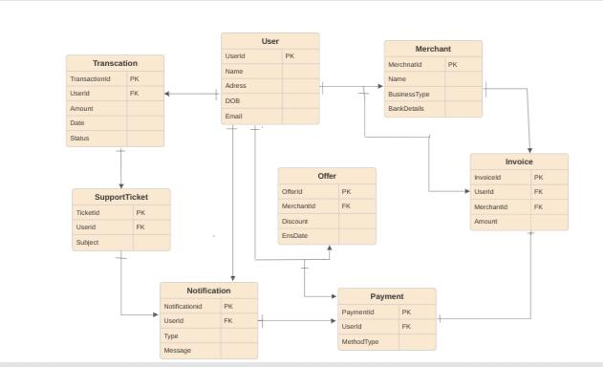

**Revenue and Profit Growth Strategies**

**Question:** After completing the product dissection and schema design steps for the chosen platform, conduct a comprehensive case study on the above chosen industry. Your goal is to identify and propose strategies to increase the **profit of the industry by at least 25%**.

1. **Analyzing Paytm’s Current Status :**

* This case study aims to propose strategies to increase **Paytm's profit by at least 25%** by analyzing its recent financial data. We will examine revenue, expenses, and profit trends, identify key areas for improvement, and recommend actionable steps with a focus on increasing operational efficiency and exploring new revenue streams:

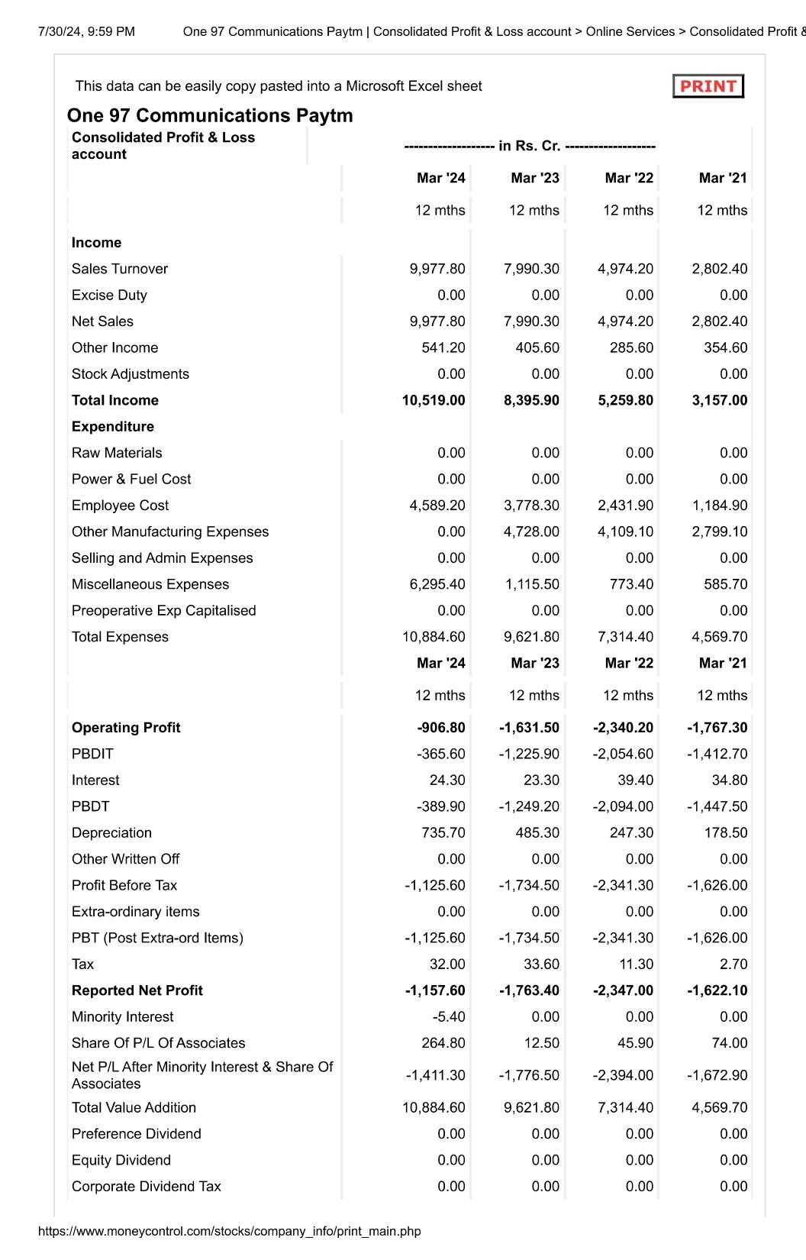

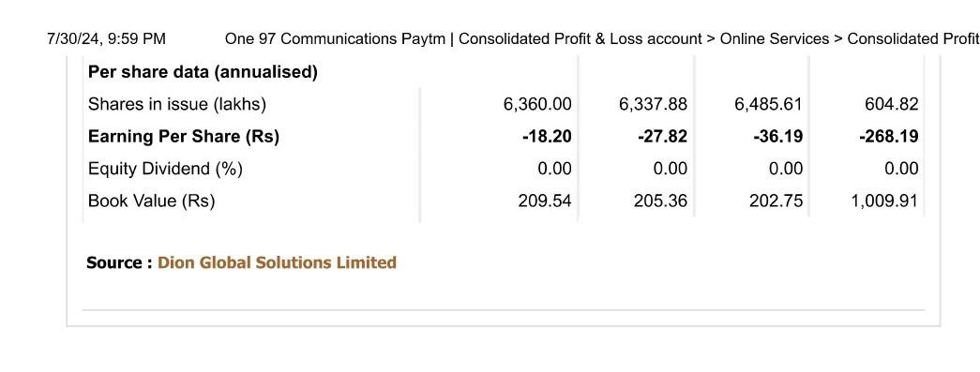

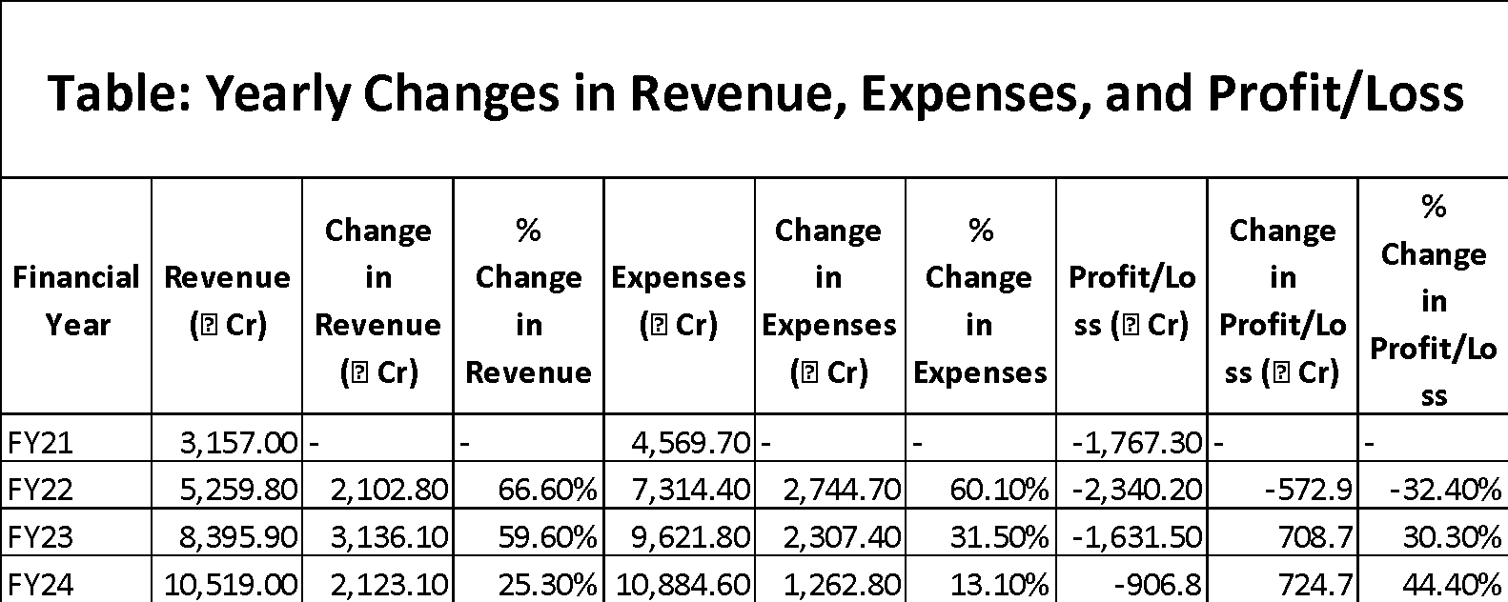

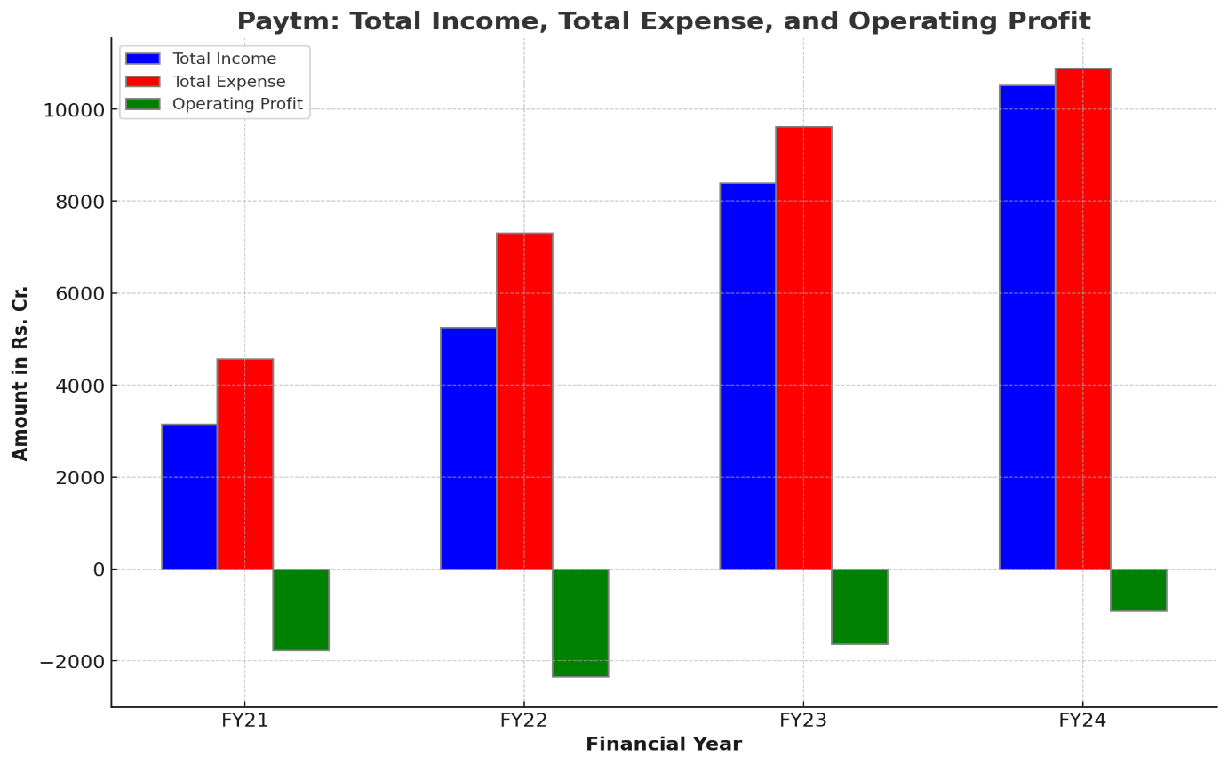

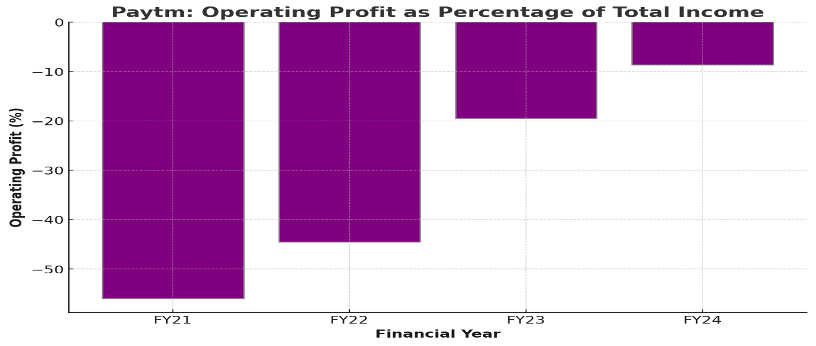

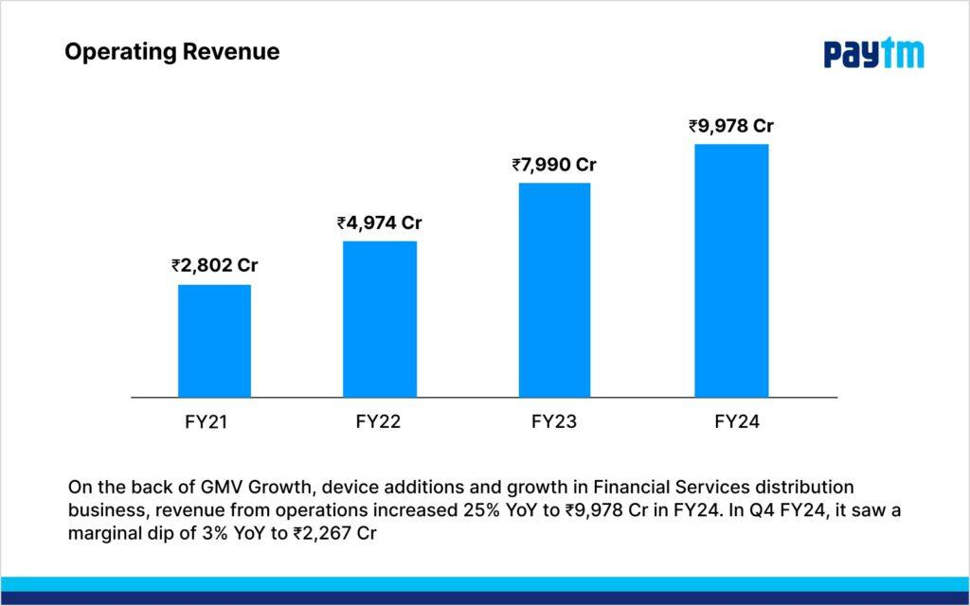

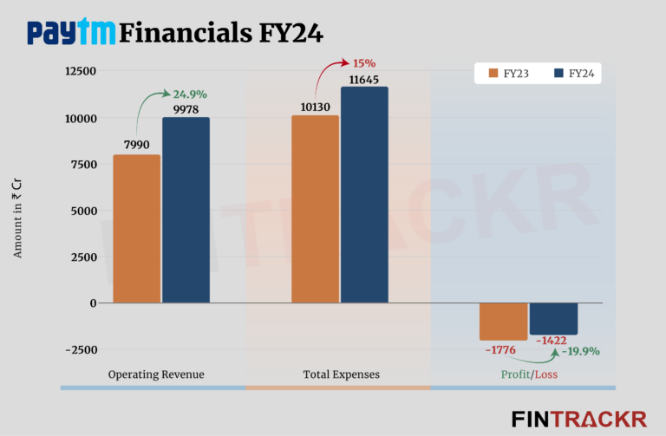

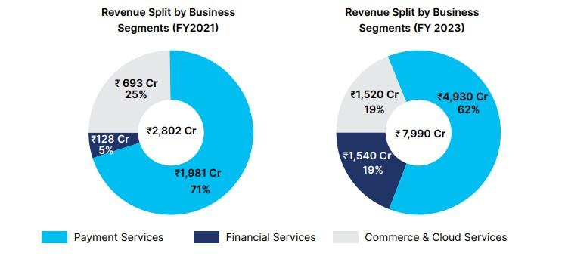

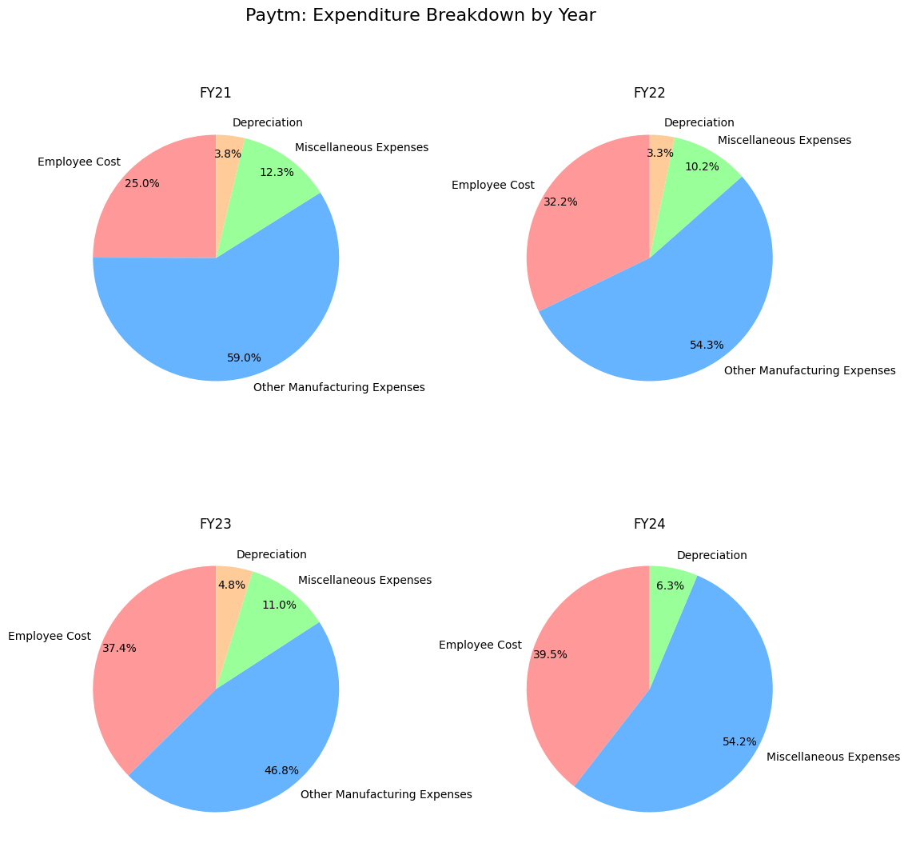

**Analysis**

**FY21 to FY22**

* **Revenue**: Increased by ₹2,102.80 Cr, a 66.6% growth.
* **Expenses**: Increased by ₹2,744.70 Cr, a 60.1% growth.
* **Profit/Loss**: The loss increased by ₹572.90 Cr, a 32.4% increase in loss.

**FY22 to FY23**

* **Revenue**: Increased by ₹3,136.10 Cr, a 59.6% growth.
* **Expenses**: Increased by ₹2,307.40 Cr, a 31.5% growth.
* **Profit/Loss**: The loss decreased by ₹708.70 Cr, a 30.3% improvement.

**FY23 to FY24**

* **Revenue**: Increased by ₹2,123.10 Cr, a 25.3% growth.
* **Expenses**: Increased by ₹1,262.80 Cr, a 13.1% growth.
* **Profit/Loss**: The loss decreased by ₹724.70 Cr, a 44.4% improvement.

**Table: Transaction Data for UPI Apps (June 2024)**

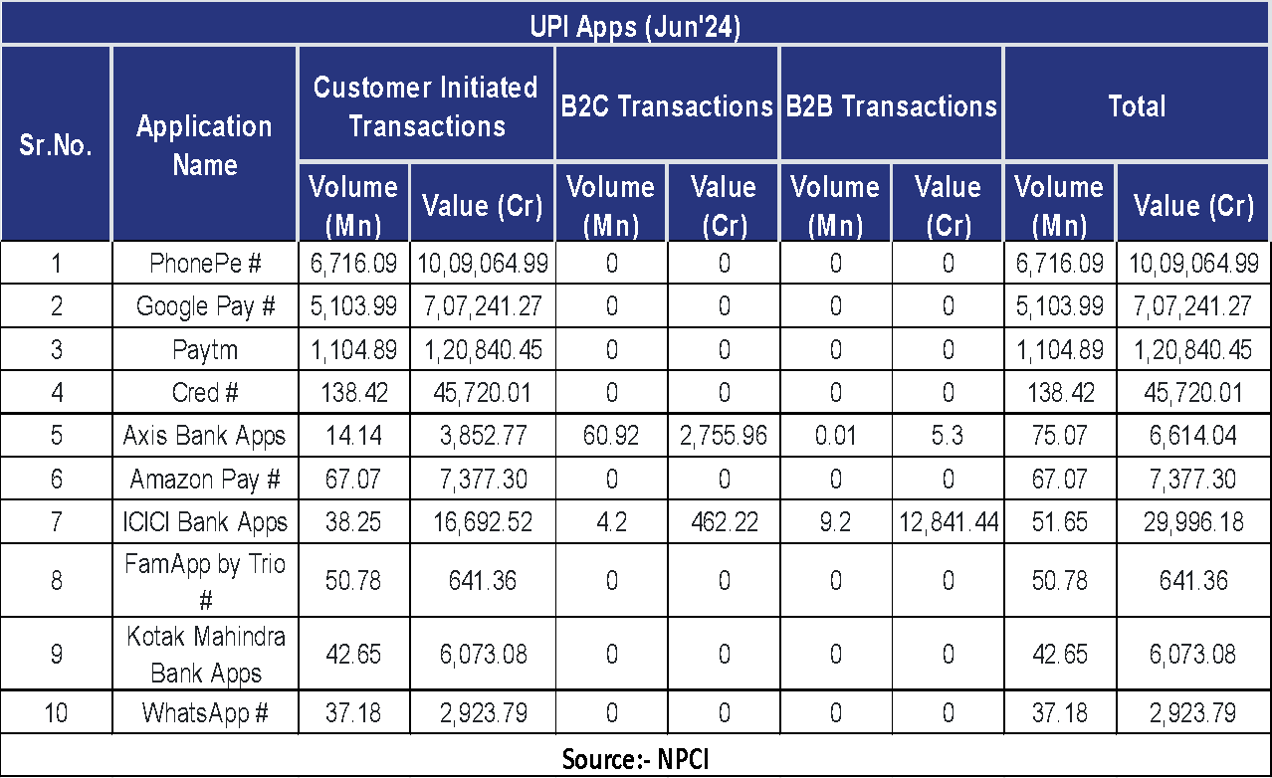

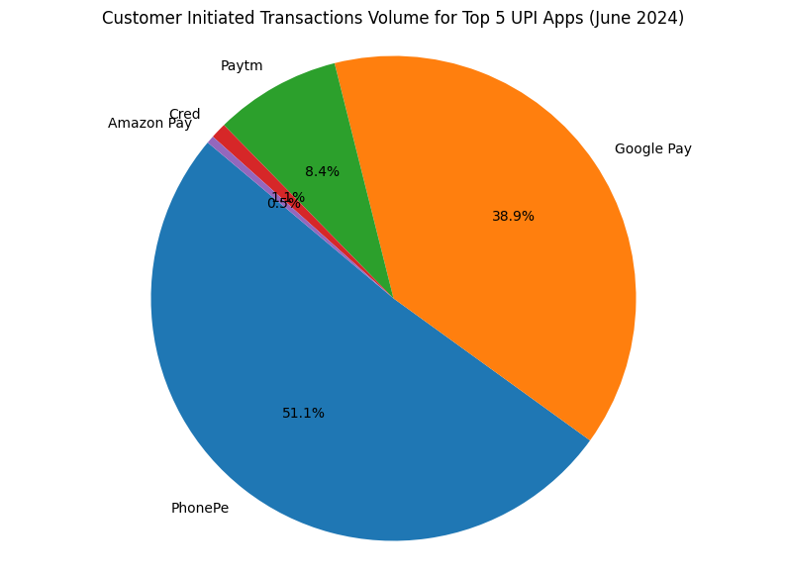

### **II. Focus Areas for Increasing Paytm's Profit by 25%**

To boost Paytm's profit by 25%, the company needs to concentrate on several critical areas. These include optimizing internal operations, refining product offerings, expanding market presence, enhancing post-sales support, and strengthening brand identity. By implementing focused strategies in these areas, Paytm can improve operational efficiency, elevate customer satisfaction, and broaden its market footprint.

| **Category** | **Focus Area** | **Measures** |
| --- | --- | --- |
| **Internal Management (~9%)** | **Operational Efficiency (~6%)** | - **Waste Management**: Use data analytics to optimize processes, reduce unnecessary expenses, and improve procurement. |
| - **Automate Processes**: Implement AI for customer support (chatbots), fraud detection, and targeted ads based on user behavior. |
| **Cost Control:** Conduct audits & Regularly review software and service contracts. Negotiate better terms for cloud services and software licenses. |
| **Employee Productivity (~3%)** | **Training Programs:** Continuous Training & Focus on improving customer service skills, fraud detection, and staying updated with financial technologies. |
| **Cross-Training**: Equip employees with skills across various roles to enhance flexibility and productivity |
| - **Performance Metrics**: Implement tracking systems for customer service, technical, and sales teams, including rewards for achieving targets. |
| **Supply Chain (~2%)** | **Vendor Management (~2%)** | - **Supplier Diversification:** Reduce dependency on a single vendor by sourcing from multiple suppliers. |
| - **Vendor Negotiation**: Renegotiate terms with vendors, look for alternative vendors offering competitive rates. |
| **Product Strategy (~6%)** | **Launch of New Products (~4%)** | - **Market Research**: Identify high-margin financial products like new insurance offerings and savings plans. |
| - **New Product Introduction**: Launch financial planning tools and premium services for businesses and health insurance products. |
| **Product Differentiation:** Develop unique features to distinguish new products from competitors. |
| **Product Optimization (~4%)** | - **Cut Down Underperforming Products**: Analyze and phase out low-demand or low-profit products, focus on high-demand, high-margin items. |
| - **Launch Combo Products**: Offer bundled services like combining transactions with insurance or investment products to increase revenue per user. |
| **Customer Feedback Integration:** Regularly gather and incorporate customer feedback to refine product offerings. |
| **Market Expansion (~4%)** | **Geographic Expansion (~4%)** | - **New Markets**: Target regions with high potential for digital payment adoption, like Tier-2 and Tier-3 cities in India. |
| - **Localized Products**: Customize financial products and marketing for regional preferences, including language support and region-specific offers. |
| **Partnerships:** Collaborate with local businesses to facilitate market entry and expand reach. |
| **Marketing Strategy (~4%)** | **Referral Programs (~2%)** | **Affiliate Marketing:** Partner with influencers and affiliates to promote the platform. |
| - **Enhanced Referral Programs**: Offer rewards to current users for bringing in new users. |
| **Customer Retention (~2%)** | - **Loyalty Programs**: Reward frequent users with cashback, discounts, and exclusive offers. |
| **Personalized Communication:** Use data to tailor marketing messages and offers to individual user preferences. |
| **Brand Awareness (~2%)** | **Content Marketing:** Develop engaging content such as blogs, videos, and infographics to build brand authority. |
| - **Targeted Advertising**: Invest in ads on social media and popular apps, highlighting ease of use, security, and benefits. |
| **Total** | **25%** |  |

**III. Defining Strategies**

| **Category** | **Details** |
| --- | --- |
| **Optimize Expenses** | **Cost Reduction:** Implement strategies to cut operational costs by renegotiating supplier contracts, optimizing logistics, and utilizing cost-efficient technologies |
| **Efficiency Improvements:** Leverage data analytics to refine inventory management practices, minimize waste, and streamline operations. |
| **Enhance Revenue Streams** | **Upselling and Cross-Selling**: Create strategies to boost the average order value by suggesting related or complementary products to customers. |
| **New Revenue Streams:** Launch new products, services, or subscription models that align with customer needs and open additional revenue channels. |
| **Pricing Strategies:** Employ dynamic pricing techniques to adjust rates in response to demand fluctuations, competitive pressures, and customer behavior. |
| **Improve Customer Satisfaction and Retention** | **Personalized Experiences:** Provide tailored recommendations and promotions to elevate customer satisfaction and foster repeat business. |
| **Customer Feedback:** Regularly collect and act on customer feedback to refine and enhance products and services. |
| **Loyalty Programs:** Develop loyalty programs that offer rewards for frequent purchases and referrals to increase customer retention. |

By implementing an **inside-out approach**, Paytm can methodically tackle critical areas to enhance profitability. Starting with expense optimization, moving on to improving customer satisfaction and loyalty, and then concentrating on expanding revenue streams, offers a systematic strategy for achieving a significant boost in profit. Leveraging data-driven insights throughout the process ensures decisions are based on reliable information, leading to more impactful and sustainable advancements. This thorough methodology will position Paytm to attain the goal of a 25% increase in profit.

**PART - II**

**Guesstimates**

1. **What will be the percentage increase in global FinTech investments over the next five years?**

* This question involves estimating the growth rate of investments in FinTech startups and companies, considering current trends and future projections.

**Step - 1: Historical Global FinTech Investment (2019-2023)**

* **2019:** The FinTech investment reached approximately $135.7 billion.
* **2020:** Investments dropped slightly to around $111.8 billion.
* **2021:** There was a significant increase to $210.1 billion.
* **2022:** Investments declined to approximately $88.8 billion.
* **2023:** Investments further decreased to about $46.3 billion.

**Step - 2:** **Annual growth rates**

* **2019-2020:** (111.8−135.7) / 135.7 ≈ −17.6%
* **2020-2021:** (210.1−111.8) / 111.8 ≈ 88.0%
* **2021-2022:** (88.8−210.1) / 210.1 ≈ −57.7%
* **2022-2023:** (46.3−88.8) / 88.8 ≈ −47.8%

**Step - 3: Average Growth Rate Calculation**

Average Growth Rate = (−17.6 + 88.0 − 57.7 − 47.84) / 4 ≈ −8.8%

**Step - 4:** **Understanding Current Trends**

The FinTech investment market has seen significant fluctuations, heavily influenced by macroeconomic factors, such as the COVID-19 pandemic and subsequent economic recovery periods. Recent trends show a considerable decline in investment, particularly due to the tightening of venture capital funding and market uncertainties.

**Step - 5.1:** **Projected Investment with -8.8% Growth Rate**

Let X be the investment at the start of 2024, and Y be the projected investment at the end of 2028.By using CAGR Formula-

Y = X × (1−0.088)^5 ≈ X×0.632

Percentage Change = (0.632−1)×100 ≈ −36.8%

Thus, if the historical average decline of -8.8% continues, the projected decrease in global FinTech investments over the next five years would be approximately **36.8%**.

**Step - 5.2: Projected Investment with 5% (by assumption) Growth Rate**

Assuming a modest recovery and stabilization, the next five years could potentially see a return to positive growth, though at a slower pace. For calculation purposes, let's assume an optimistic average growth rate of 5%.

For a base investment value X in 2023 and using a CAGR of 5%:

Y = X × (1+0.05)^5 ≈ X×1.276

Percentage Change = (1.276−1)×100 ≈ 27.6%

Thus, under optimistic conditions and assuming stabilization in the market, the projected increase in global FinTech investments over the next five years could be around **27.6%**.

**Step - 6:** **Projected Global FinTech Investment (2024-2028) Under Two Different Growth Scenarios**

| Year | Investment (Assuming -8.8% CAGR) | Investment (Assuming 5% CAGR) |
| --- | --- | --- |
| 2023 | $46.3 billion | $46.3 billion |
| 2024 | $42.4 billion | $59.0 billion |
| 2025 | $38.8 billion | $75.1 billion |
| 2026 | $35.4 billion | $95.6 billion |
| 2027 | $32.4 billion | $121.5 billion |
| 2028 | $29.6 billion | $154.2 billion |

This table assumes a starting investment of $46.3 billion for 2023. The "Investment (Assuming -8.8% CAGR)" column shows the projected investments based on a continued decline of 8.8% annually, while the "Investment (Assuming 5% CAGR)" column shows projections assuming a 5% annual growth rate over the same period.

1. **How many people will adopt digital banking services in developing countries over the next decade?**

To estimate the number of people who will adopt digital banking services in developing countries over the next decade, we need to consider several factors including current adoption rates, population growth, internet and smartphone penetration, and efforts by governments and private companies to promote financial inclusion.

Here’s a step-by-step approach to arrive at a guesstimate:

### **1. Current Population of Developing Countries**

* Assuming the current population of developing countries is approximately 6 billion people.

### **2. Current Adoption Rate of Digital Banking**

* Let's assume that currently, around 20% of the population in developing countries uses digital banking services. This gives us 1.2 billion users.

### **3. Projected Population Growth**

* The population in developing countries is expected to grow at an average rate of around 1% per year. Over 10 years, this results in a population increase of about 10%. So, the population will be around 6.6 billion by the end of the decade.

### **4. Internet and Smartphone Penetration**

* Internet and smartphone penetration are critical factors. Assume the current penetration rate is around 50% and is expected to increase to 80% over the next decade due to decreasing costs and improving infrastructure.

### **5. Government and Private Initiatives**

* Assume that efforts to promote financial inclusion will significantly impact adoption rates. Let's assume these initiatives will lead to a 30% increase in digital banking adoption among those with internet and smartphone access.

### **6. Calculation of New Users**

* Current number of users: 1.2 billion
* Population increase: 6 billion * 10% = 600 million
* New population: 6.6 billion
* Projected internet and smartphone users: 80% of 6.6 billion = 5.28 billion
* Increase in adoption rate due to initiatives: 30% of 5.28 billion = 1.584 billion new users

### **7. Total Estimated Users**

* Current users: 1.2 billion
* New users: 1.584 billion

**Total estimated users of digital banking services in developing countries over the next decade:**

* 1.2 billion (current users) + 1.584 billion (new users) = 2.784 billion

Thus, approximately **2.8 billion** people are estimated to adopt digital banking services in developing countries over the next decade.

1. **What percentage of small and medium-sized enterprises (SMEs) will use FinTech solutions for their financial needs by 2025?**

* This question involves predicting the adoption rate of FinTech services among SMEs, including payments, lending, and financial management tools.

**Answer:**

To forecast SME adoption of FinTech solutions by **2025**, we start with an assumed current rate of adoption. Applying an assumed annual growth rate using the CAGR formula, we can calculate the adoption rate over the next year.

| **Process** | **Details** | **Calculation** |
| --- | --- | --- |
| Current Adoption Rate | Assume 45% of SMEs currently use FinTech solutions. | **= 45%** |
| Growth Rate of FinTech Adoption | Annual growth rate of 11%. | **= 11%** |
| Time Period | Estimating for the year 2025, which is 1 year from now. | **= 1 year** |
| Calculate Future Adoption Rate | Using the CAGR formula to estimate the future adoption rate. | **=** **Present Value × (1+GrowthRate)Number of Years**  **= 45 x (1 + 0.11)1**  **= 49.95 %** |
| Result | Future Adoption Rate of SMEs using FinTech solutions by 2025 | **≈ 49.95%** |

**CAGR = Present Value × (1+GrowthRate)Number of Years**

To project the adoption rate of FinTech solutions among SMEs by **2025**, we start with a current adoption rate of **45%**. Assuming an annual growth rate of **11%**, we use the CAGR formula to estimate the future rate. Over a **1-year** period, this growth translates to approximately **49.95%**. Thus, by **2025**, it's anticipated that around **50%** of SMEs will utilize FinTech solutions.

1. **What will be the average transaction value of mobile payments in the next three years?**

* This question requires estimating the average amount of money transacted through mobile payment platforms, considering the growth of mobile commerce and digital wallets.

**Answer:**

**Step 1: Average annual transaction value per person (source: statista industrial report)**

Examine Historical Trends in Average Mobile Payment Transaction Values Over Recent Years

⦁ **2017:** $1100

⦁ **2018:** $1200 (9% up)

⦁ **2019:** $1330 (10.8% up)

⦁ **2020:** $1510 (13.5% up)

⦁ **2021:** $1680 (11.2% up)

⦁ **2022:** $1860 (10.7% up)

⦁ **2023:** $2060 (10.7% up)

**Step 2: Average Annual Growth Rate**

Calculate the average annual growth rate for the past four years.

Average Growth Rate = (13.5%+11.2%+10.7%+10.7% = 11.4%

**We can consider 11.5% as an average growth rate.**

**Step 3: Assess Current Trends:**

**Evaluate Key Factors Influencing Mobile Payments:**

⦁ **Technological Advancements:** Ongoing innovations in mobile payment systems, digital wallets, and security measures.

⦁ **Regulatory Environment:** Enhanced regulatory support for mobile payment systems.

⦁ **Consumer Adoption:** Increasing usage of mobile payments driven by convenience and ease of access.

⦁ **Economic Factors:** Global economic conditions impacting consumer spending habits.

Assume these key factors influence the average growth rate for +2%.

**Adjusted Growth Rate:** Adjusted Growth Rate=11.5%+2%=13.5%

**Step 4: Calculate the Average Transaction Values for the Next Three Years**

Using the adjusted growth rate of 13.5%, apply the formula for compound growth to estimate the values.

**Formula:** Future Value=Current Value × (1+Growth Rate)

**Growth Rate in Decimal Form:** Growth Rate=13.5/100=0.135

**2024**

Value=2060 × (1+0.135) =2339.10

**2025**

Value=2339.10 × (1+0.135) =2658.69

**2026**

Value=2658.69 × (1+0.135) =3015.46

**Conclusion:**

By 2026, the average transaction value per person is expected to increase to around $3015.46, based on an annual growth rate of 13.5%.

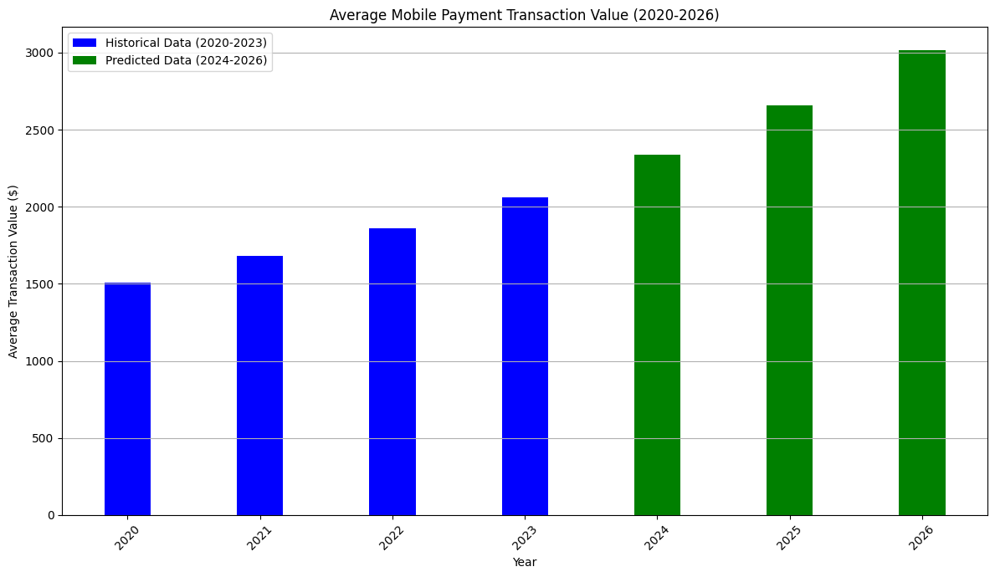

1. **How much will blockchain technology reduce the costs of cross-border transactions in the next five years?**

This question involves estimating the cost savings achieved through the adoption of blockchain technology for international money transfers, factoring in current fees and the efficiency improvements brought by blockchain

**Answer :-**

* **Blockchain technology is a decentralized digital ledger system that records transactions in a secure, transparent, and immutable way.**
* **Reduces the need for intermediaries and speeds up transactions.**

Let's look at the practical example to illustrate how blockchain technology might reduce the cost of cross-border transaction : -

**Example : - Cross-Border payment from US to India.**

**Traditional Method:-**

* Transaction Amount : $10,000 USD
* Bank Fees : Bank might charge flat fee of 30$-50$ of the transaction amount(1-3%)
* FX fees : Bank may charge additional fee (1-2%)
* Processing time : It can take 3-5 days.

**Total Cost with Traditional Method:**

* Flat Fees: $50
* Percentage Fees (1.5% of $10,000): $150
* FX Margin (1.5% of $10,000): $150
* Total Cost: $50 + $150 + $150 = $350

**Blockchain technology :-**

* Transaction Amount : $10,000 USD
* Blockchain fees : Let;s assume a fee of $5 for blockchain.
* FX fees : It offers better exchange rates with lower margin (around 0.5%)
* Processing time : Transaction can be completed in minute to hour.

**Total Cost with Blockchain-Based Method:**

* Flat Fees: $5
* Percentage Fees (0.5% of $10,000): $50
* FX Margin (0.5% of $10,000): $50
* Total Cost: $5 + $50 + $50 = $105

**Cost Comparison:**

* **Traditional Method Total Cost: $350**
* **Blockchain-Based Method Total Cost: $105**
* **Savings: $350 - $105 = $245**

In this example, the blockchain-based method results in a **cost reduction of about 60%** compared to the traditional method.

In the above example you have seen how blockchain technology can reduce the cost of cross-border transactions for only one transaction .

**So now we have to check for the next five years how blockchain technology reduces the cost of cross-border transactions?**

| **Steps** | **Detail** | **Calculation** |
| --- | --- | --- |
| Current cross-border transaction | Define the current average cost of cross-border transaction | Assume the average cost is 5% of the total amount. |
| Define cost reduction through blockchain | Estimate cost saving brought by blockchain | Assume blockchain can reduce cost by 50%. |
| Cost of cross-border transaction after applying blockchain technology | Calculate new cost of cross-border transaction after applying the cost reduction | Cost = 5% * (1- 0.50) =5% * 0.50  = 2.5% |
| Current volume of cross-border transaction | Estimating current total volume of cross-border transaction | Assume the current volume is $5 trillion annually. |
| Projected volume of cross-border transactions over next five years. | Calculate the growth in volume of cross-border transaction | Future volume=5 trillion*(1+0.05)^5    = **$ 6.38 trillion** |
| Final Cost Saving | Calculate total cost savings achieved through blockchain for next five years. | Total cost Saving=6.38 trillion * (5%-2.5%) =6.38 trillion * 0.048    = **$ 306 billion** |

**Conclusion : -**

Based on the above calculation,Blockchain technology is projected to reduce the cost of cross-border transactions by approximately **$ 306 billion over the next five years** by considering a **cost reduction of 50%** from the average cost.